Configuring Port-Security (Instructor Version)
Completed Topology
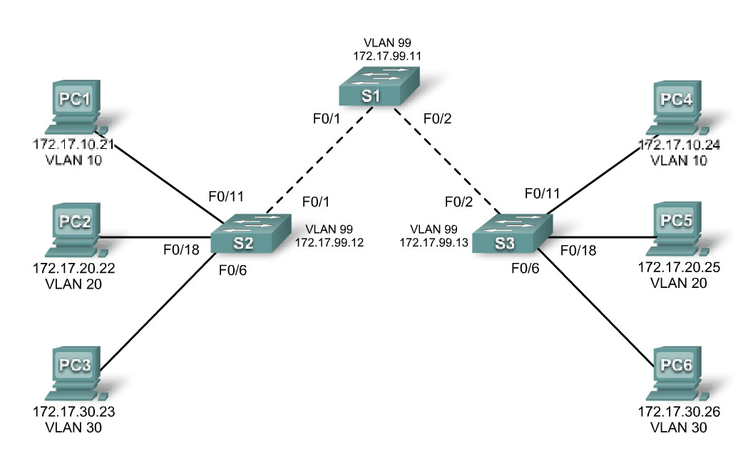
Objectives
- View the default Layer 2 configuration.
- Configure port security.
Background/Scenario
Port security enables the switch administrator to prevent unauthorized devices from gaining access to the network. Port security is normally enabled on access layer switches for this purpose.

NOTE: This activity is for observation purposes only and does not require configuration, thus grading will not be conducted.

Task 1: View the Default Configuration.

Step 1. Verify the trunking and VLAN configuration on the switches.
- On the three switches, enter privileged EXEC mode using the console password cisco and the secret password class.
- From privileged EXEC mode, issue the show interfaces trunk and show interfaces switchport commands.
Observation: On S1, ports F0/1 and F0/2 are 802.1Q trunk ports. On S2, port F0/1 is an 802.1Q trunk port. On S3, port F0/2 is an 802.1Q trunk port. The native VLAN is 99 for all trunk ports.
- Issue the show vlan command to verify proper VLAN configuration.
Observation: VLANs 10 (faculty/staff), 20 (students), 30 (guest), and 99 (management) are configured on the three switches: VLAN 1 is the default VLAN on each switch.
S1 VLAN 1: all ports except for trunk ports F0/1 and F0/2.
S2 VLAN 1: ports F0/2-5, G1/1-2.
S2 VLAN 10: ports F0/11-17
S2 VLAN 20: ports F0/18-24
S2 VLAN 30: ports F0/6-10
S3 VLAN 1: ports F0/1, F0/3-5, G1/1-2
S3 VLAN 10: ports F0/18-24
S3 VLAN 20: ports F0/11-17
S3 VLAN 30: ports F0/6-10

Step 2. Verify the VTP configuration on the switches.
- From privileged EXEC mode on the access layer switches, issue the show vtp status command to verify VTP modes and VLAN information.
Observation: S1 is a VTP server. S2 is a VTP client. S3 is in VTP transparent mode. The VLANs configured on S1 successfully propagated to S2.

Step 3. Verify IEEE 802.1D spanning-tree.
- From each switch, issue the show spanning-tree command.
- Verify that all switches are running IEEE 802.1D spanning-tree.
- Verify that S1 is the root bridge for VLANs 1-1001.
Observation: All switches are running IEEE 802.1D. S1 is the spanning-tree root bridge for the topology.

Task 2: Configure port security on the switches.

Step 1. Enable port security on S2 and enforce a maximum number of MAC addresses.
- To enable port security on S2, enter the interface mode for port F0/6 and issue the command switchport port-security.

- Repeat step 1.a. on ports F0/11 and F0/18 of S2.

- On ports F0/6, F0/11, and F0/18 of S2, enter the command switchport port-security maximum

- Enter the show run command in privileged EXEC mode to see the effect of step 2.a.

Observation: The command switchport port-security maximum 1 does not appear under the interfaces F0/6, F0/11, and F0/18. This is because the default maximum for port security on an interface is 1. The command switchport port-security maximum # will only appear if a value higher than 1 is configured.
- Repeat steps a through d on ports F0/6, F0/11, and F0/18 of switch S3.

Step 2. Configure dynamic learning for port security and verify operation.
- On ports F0/6, F0/11, and F0/18 of S2 and S3, enter the command switchport port-security mac-address sticky. Issue the show run command to view the final configuration on both S2 and S3.

- Click on PC6. PC6 is currently connected to Fa0/6 on S3. From the command prompt on PC6, issue the command ping 172.17.30.23. This will ping PC3, which is connected to Fa0/6 on S2. The ping should be successful.

- On S2 and S3, enter the command show run and check to see if anything has changed in the output.

Observation: On S2, the entry “switchport port-security mac-address sticky 0001.C7CA.E31C” now appears under the configuration for port F0/6. On S3, the entry “switchport port-security mac-address sticky 0030.A3A5.A8C2” now appears under the configuration for port F0/6.

- On S3, enter the command show port-security interface fa0/6.

Observation: Port security is enabled, port-status is secure-up, security violation count is 0.

Step 3. Observe what happens when a security violation occurs.
- Click on the red x button on the right hand portion of the PT window. This will allow you to delete a connection in the topology. Place the x over the connection between PC6 and S3 and click. The connection should disappear.

- Select the lightening bolt button on the bottom left-hand corner of the PT window to pull up connection types. Click the “copper straight-through” connection. Click the TestPC device and select the fastethernet port. Next, click on S3 and select port Fa0/6.

- From the command prompt of TestPC type the command ping 172.17.30.23. The ping should fail.

- On S3, enter the command show port-security interface fa0/6.

Observation: Port security is enabled, port-status is secure-shutdown, security violation count is 1.

- Delete the connection between TestPC and S3. Place a new connection between PC6 and S3 using port Fa0/6. Remember that once a port is shutdown due to a security violation, the port must be administratively shutdown and re-enabled to bring the port back online. On Fa0/6 on S3, issue the command no shutdown.

- From the command prompt on PC6, type the command ping 172.17.30.23. The ping should succeed. On S3, issue the command show port-security interface Fa0/6. The status of the port should be back to normal.

You have completed this configuration/observation activity.

